**Exercise: Filtering data**

[Adventure Works Inventory1](https://d3c33hcgiwev3.cloudfront.net/b_sNJdnFQM2vKuXvQZBQGw_0ea967adad6b4836a39dbee9498609e1_Adventure-Works-Inventory1.xlsx?Expires=1732579200&Signature=YGT36p6zCuRlNzgB7P6vVVnBWg03MlQ2b2p0kLCuNp4zaOU3Z7yLt8herWHyVqwMw659nkQ1hEvvmwVDh8KE0djzig93fdfctPh3E27K~jPfZnpIMJSZlH-ZCR0GCgd0~jXRCLDAhq1GWmxJG3Kab-4BXrM65fF3TxNDRjgeeOg_&Key-Pair-Id=APKAJLTNE6QMUY6HBC5A" \t "_blank)

[XLSX File](https://d3c33hcgiwev3.cloudfront.net/b_sNJdnFQM2vKuXvQZBQGw_0ea967adad6b4836a39dbee9498609e1_Adventure-Works-Inventory1.xlsx?Expires=1732579200&Signature=YGT36p6zCuRlNzgB7P6vVVnBWg03MlQ2b2p0kLCuNp4zaOU3Z7yLt8herWHyVqwMw659nkQ1hEvvmwVDh8KE0djzig93fdfctPh3E27K~jPfZnpIMJSZlH-ZCR0GCgd0~jXRCLDAhq1GWmxJG3Kab-4BXrM65fF3TxNDRjgeeOg_&Key-Pair-Id=APKAJLTNE6QMUY6HBC5A" \t "_blank)

**Introduction**

By now, you should be familiar with the filtering feature in Microsoft Excel. This feature allows you to organize content so that you can read and identify data quickly and efficiently. This makes it easier to analyze your data.

In this exercise, you’ll use the filters to find key information in the worksheet data. By the time you complete this activity, you’ll be able to use the filter technique to perform a simple analysis of the information in the worksheet.

**Case study**

Jamie from Adventure Works has emailed you questions about the inventory file you are working on.

She needs you to find the following numbers and submit them to her:

* The number of listings for gear components.
* The number of orders placed with Z123 in 2023.
* The number of orders placed with Z123 in 2022.
* The number of orders for mountain bike frames.
* The number of mountain bike orders with a stock level of over 500.

You will need to use the **Filter** feature to extract the information from the file required to answer these questions.

**Step 1: Download and customize the file**

1. Download and open the Microsoft Excel workbook *Adventure Works Inventory1.xlsx.* The file should contain one worksheet named **Products** that consists of 151 rows and 9 columns. You may have used a file with similar content in a previous exercise. However, Adventure Works requires you to complete a different set of tasks for this exercise.

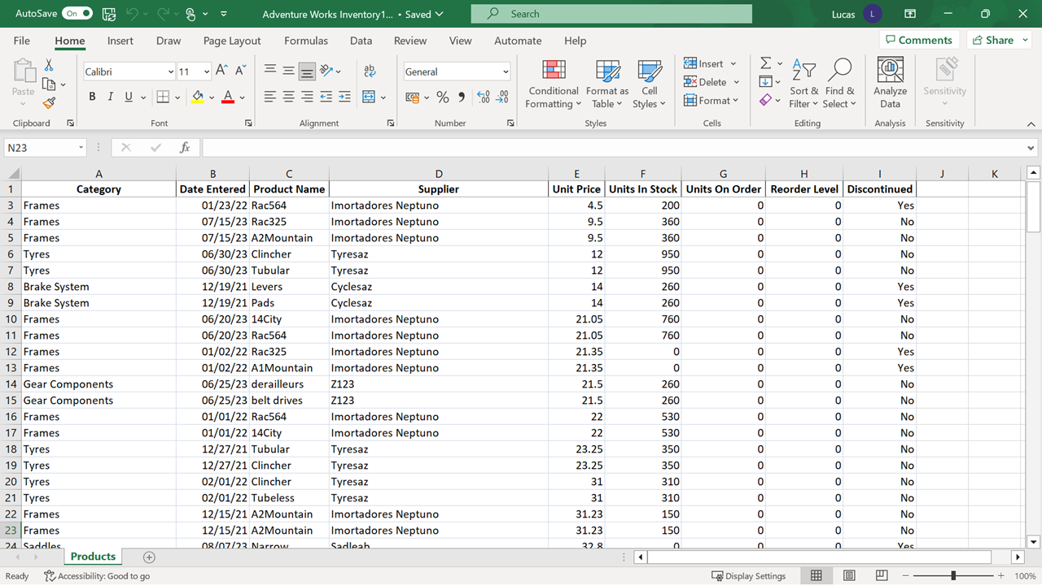

**Step 2: Filtering the data**

**Tip:** Remember to clear all **filters** in between steps. To confirm how many records are in the filter results, check the count on the left-hand side of the bottom row of the Excel screen.

1. Turn on **Filtering**.

**Tip:** The **Filter** button is in the **Data** tab.

1. Identify how many gear components are listed.

**Tip:** Ensure that only gear components are selected in the drop-down on **Category** before applying the filter.

1. **Filter** to establish how many orders were placed with **Z123** in **2023**.
2. Change the **Filter** to confirm how many orders were placed with **Z123** in **2022**.

**Tip:** Only adjust one of the filters.

1. **Filter** the data to identify how many orders of mountain bike frames are in the worksheet.

**Tip:** Be aware of the different versions of the mountain bike frame listed. Use the **Text Filter** additional filter choice on **Product Name**. Don’t clear the **Filter** before completing the next task.

1. Use the **Filter** to determine how many of the mountain bike orders have a stock levelof over 500.

**Conclusion**

You have now found the information to submit to Jamie at Adventure Works. By completing this exercise, you have applied filtering techniques that will help you to work more efficiently with large worksheets and to find answers to questions in the data. This is a starting point for data analysis.

Mark as completed

Like

Dislike

Report an issue